en
PASSPORT No. SAEF |  | SIGNATURE & STAMP OF THE SOUTH AFRICAN EQUESTRIAN FEDERATION
NAME OF HORSE KAYWILHA ZHARA
CHANGE OF NAME & DATES  PREFIX/SPONSOR |  | MICROCHIP NO I I I I I I I I I I I
 |  | THE HEIGHT OF THE HORSE IS REQUIRED ON PAGE 24
YEAR OF  BIRTH  19/11/2022 | COUNTRY OF BIRTH  RSA | BREED  SIRE | ARAB | PP NUMBERS
SEX  MARE | COLOUR  BAY | DAM
SEX  MARE | COLOUR  BAY | SIRE OF DAM
DESCRIPTION OF MARKINGS - USE BLOCK CAPITALS ONLY AND COMPLETE OUTLINE DIAGRAM
HEAD UPPER EYE LEVEL CURVED STAR
NECK
LEFT FORE PASTERN WHITE HOOF
RIGHT FORE BLACK HOOF
LEFT HIND BLACK HOOF
RIGHT HIND PASTERN WHITE
BODY
ACQUIRED (BRAND/FREEZE MARKS OR PERMANENT SCARS)

a,

C:
�u 0
-
.c
a,
.c:
-
a,

"O
"iii
:,
0

"O
a,
� 0
0
.!!! 0)

C:
:.::
·;::
�
0z-
-0
.c:
-
a, 0

C:
a,en 0
a,
a..

Outline diagram

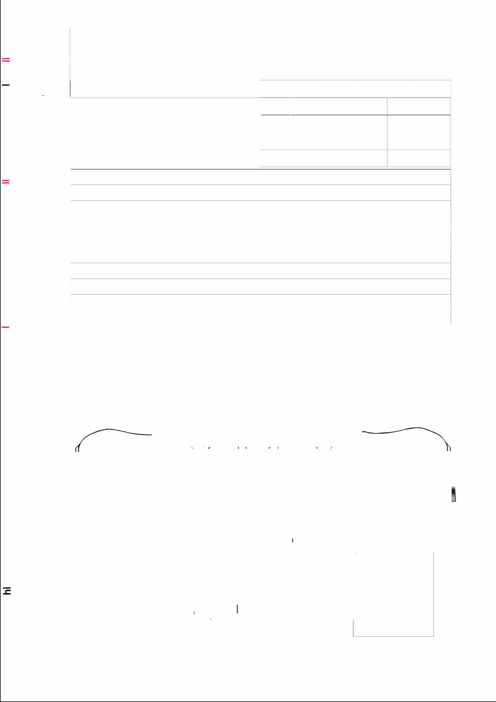
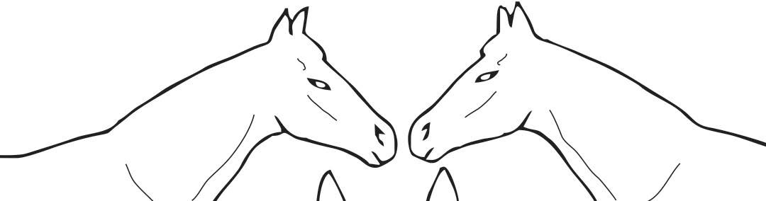
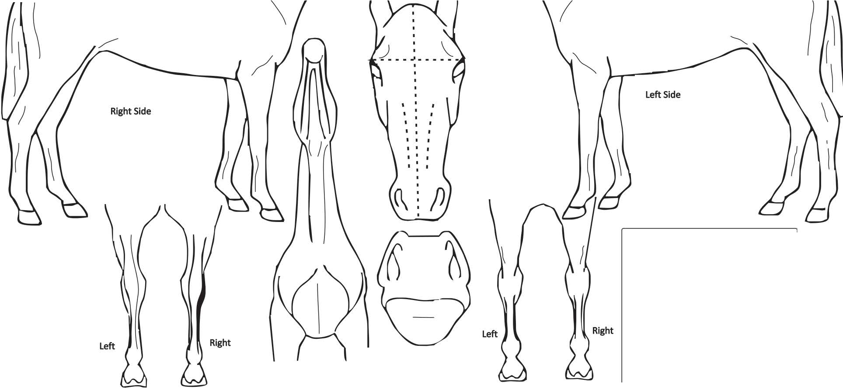
Cw 0:::
·-

C:
a,

C: 0 "O
a,
-
.c
0
en
0)
:S2C:....
0E
-
a,
3:

Hind - Rearview

NeckLowerview

Muzzle

Upper EyeLevel

Fore-Rearview

Signature and stamp veterinarian

Place & date

